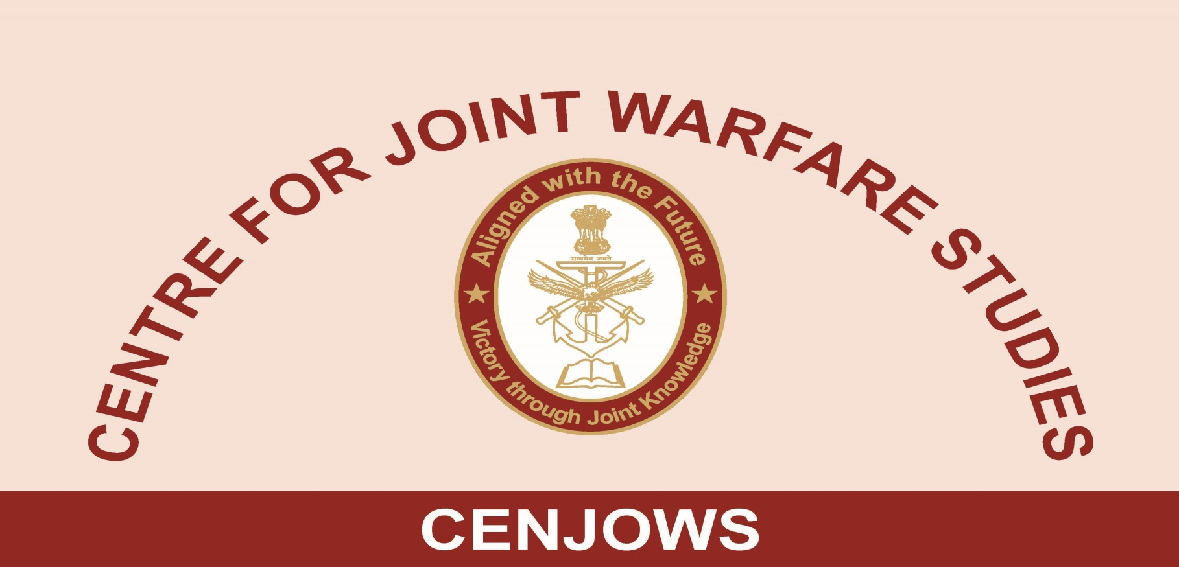
PROCEEDINGS OF ROUND TABLE DISCUSSION ON
“INDIA AND STRATEGIC AUTONOMY”
BY
GP CPAT GD SHARMA, VSM (RETD)

07 FEB 2019
1. Centre for Joint Warfare Studies (CENJOWS) conducted a Round Table Discussion (RTD) on 07 Feb 2019 at the Purple Bay, Jodhpur Officers Hostel, India Gate on a contemporary subject of ‘India and Strategic Autonomy’ which has become a subject of interest after India signed three foundational agreements with the United States and is seen as significant India’s tilt towards United states by the some members of the strategic community despite India’s proclaimed stance of pursuing a policy of Strategic Autonomy (SA).

2. The proceedings commenced with the introductory remarks by the Lt Gen Vinod Bhatia, PVSM, AVSM, SM (Retd), Director, CENJOWS who welcomed the audience and spoke on the growing stature of India amongst the world community in terms of its size, economy, military and moral standing. We do not have military alliance with any nation but, are strategic partner of over two dozen countries. After Directors opening talk, the topic for RTD was briefly presented to the audience by Gp Capt GD Sharma, VSM (Retd), Senior Fellow CENJOWS highlighting areas requiring deliberations by the panel of the experts who were invited to discuss the topic.

3. A panel of expert speakers from diverse backgrounds namely, Amb Rajiv Bhatia, IFS (Retd), Prof. Chintamani Mahapatra, PhD from JNU, Maj Gen Dipankar Banerjee, Founder Think Tank IPCS and Mr Nitin Gokhle, Chief Editor SNIwire News were invited to speak on the subject and specifically look at the queries raised on the subject in the concept note. These are reproduced below:-

(a) Examine the veracity of the perception on India’s strategic autonomy?
(b) Examine the belief of some strategists that Non-Alignment (NA) of yesteryears and present concept of strategic Autonomy (NA) are Synonymous?

(c) A global multi-polar system is emerging with the rise of China and India. This has shifted the focus of global politics from the Atlantic to the Pacific. In that India has emerged as a balancing power in the IOR and naturally has been sought by other powers with interest in Indo- pacific region. Examine its impact on India‘s policy of strategic autonomy?

(d) During the Cold War, when the world was divided into two hostile camps, it obviously served our interest not to be dragged into external entanglements. The cold war scenario seems to be re-emerging with China and Russia on one side and United States on the other, your views/prognosis to deal with this environment?

(e) Our core interest lies in seeking an external environment that supports the transformation of India, and enables us to build a modern, prosperous and secure country, with rightful place in the world. Can we evolve without external support from the like-minded countries?

(f) India has reached a stage that America, Russia, China, Japan and European Union all want to partner India. How are we to avoid alliances? Is non-alignment in 21stcentury an option?

Issues with Commonality in Views

4. All speakers were of the view that India retains its strategic autonomy and quoted many examples in support. In particular, a reference was made to PM speech at Shangri-La dialogue in Jun 2018 at Singapore and at Raisina dialogue held recently wherein, India stance was termed by the Foreign Secretary as a Decisional Autonomy. We have professed against military alliances and are willing to cooperate and collaborate with all. Our Prime minister’s informal meetings with the head of states of China, Russia and Japan during the previous year prove this point. Though Qatar, Saudi Arabia, Iran, Palestine and Israel have strong disagreements with each other, we have close relationship individually with all of them. Similarly, we have not hesitated to conclude military weapon purchase deal with Israel, Russia and United states as long as it was in our national interest. All speakers agreed that that there is no state with absolute strategic autonomy as all states will have some compulsion to attend to which will preclude such status.

Divergent Views

Prof. Chintamani Mahapatra

5. In the nascent years after independence, we could not afford to get dragged in to alliances but now, we should not opposed to an alliance as long as it is in our national interest. He qualified it by bringing out that there is no permanency in alliance. To support his view, he quoted the example of Philippines which since cold war period is in alliance with United States but, it did not hesitate to tell United States to shift its bases. He asserted that we need to act as per our stature and strength which is considerable and build relationships with other nations from the position of strength. Our poverty and other shortcomings should not guide our relationships as all countries have these shortcomings to some measure.

6. The other point is about our national attitude of risk aversion. Strategic autonomy denotes our risk aversion. What worst could happen if we get in alliance? We could enter in to alliance in our terms and leave it at will. He quoted the example of some NATO members who despite being part of NATO have not joined the all operations. Similarly, China has alliance with Russia but, has it lost its autonomy?

Maj Gen Dipankar Banerjee, AVSM (Retd)

7. He defined the strategic autonomy as an inherent quality for sovereignty and independence of a nation state which is must provide its citizens a secure and an increasingly prosperous and fulfilling lives. Accordingly The Strategic autonomy is a necessary attribute of nation state. Building military capability and partnerships with states is possible but not the military alliances and military groupings. However, he agreed that absolute strategic autonomy is not a possible by any state. Contrary to strategic autonomy, a non aligned state does not take sides in conflicts and may even reduce military commitments. Our first Prime minister has known to have antipathy towards military but, paradoxically we had to depend on military intervention in Kashmir in 1948 and in all conflicts thereafter.

Amb Rajeev Bhatia, IFS (Retd )
8. He opened his debate with the following assertions:-
(a) Global politics has gone through three main phases since WWII:

- 1945-89: Bipolarity.
- 1989-2008: Unipolarity.
- 2008-2019: Multipolarity.
(b ) India's manner of relating to the world contains both constant and new features, ranging from the Non-Alignment to Strategic Autonomy.

(c) A quick reading of the reference to SA in PM Modi’s Shangri-La address should be instructive: -

(i) “Beyond East and Southeast Asia, our partnerships are strong and growing. It is a measure of our strategic autonomy that India’s Strategic Partnership, with Russia, has matured to be special and privileged.”

(ii) “Ten days ago, in an informal summit at Sochi, President Putin and I shared our views on the need for a strong multi-polar world order for dealing with the challenges of our times. At the same time, India’s global strategic partnership with the United States has overcome the hesitations of history and continues to deepen across the extraordinary breadth of our relationship. It has assumed new significance in the changing world. And, an important pillar of this partnership is our shared vision of an open, stable, secure and prosperous Indo-Pacific Region. No other relationship of India has as many layers as our relations with China. We are the world’s two most populous countries and among the fastest growing major economies. Our cooperation is expanding. Trade is growing. And, we have displayed maturity and wisdom in managing issues and ensuring a peaceful border.”

9. Responses to Specific Queries in the Concept Note (Para 3 above)

(a) SA defines the Indian foreign policy of today. It is a valid policy response/strategy in the world stamped by VUCA (Volatility, Uncertainty, Complexity and Ambiguity).

(b) NA and SA are not synonymous: In appearance, the two are different –the one non-alignment, the other multi-alignments; the one in the bipolar world, the other in the multipolar world; the one where India acted as a key leader of the South, the other where India is a leader among select powers (both of the Global South and among today’s major power centers). In essence, the two are similar in the sense that both assume India would judge issues and relations on merit, not on the dictates of other powers. SA is all about issue-based alliances.

(c) There were three phases in the evolution of NA: 50s – India's high moral and political standing (Bandung); 60s – post-1962 syndrome; 70s – when our NA had a clear pro-Soviet Union tilt. Now too our SA seems to change colour frequently, depending on turns and twists of global politics. Both concepts involve Resilience, Dynamism, Pragmatism, and they both avoid static stances. Both are susceptible to the unspoken accusation that India is not a reliable partner!

(d) India in Indo-Pacific: It is not a lone balancer; it is part of a strategy to counter China. In the future, the QUAD will become effective in proportion to China's aggressive behaviour. Similary,in the Indian Ocean region India is not a lone balancer. It is a contender as a major resident power to curb China's influence. It will succeed only with the help of others – US, France, UK, key IORA players etc.

(e) New Cold war between US, and Russia/China: Too early to determine its contours and impact, especially due to the uncertainty about the wildly fluctuating US-China relationship. Will the current trade disputes end up in a deal or greater confrontation? Trump is a wild card! And the US begins the election season.

(f) No, of course we cannot develop without external support. We need technology, capital, markets, skills, defence equipment, international networking, and global cooperation to resolve global issues. Hence, SA with pro-active international engagement with all continents should be our goal.

(g) Partnerships, not alliances, represent the way out. We can have them with all major power centers. Our Chairmanship of G20 in 2022 and advance preparations involve a huge responsibility. Internally, we need a mechanism (both in the government and at Track II level) that guides the nation to manage the complex web of India's partnerships.

10. Mr. Nitin Gokhle, Chief Editor SNIwire News
(a) He agreed that India’s stance from old non-alignment has changed to multi-alliance with several nations. In fact, our foreign secretary referred it as Decisional Autonomy in the Raisina dialogue.

(b) Our character has also changed from previous years risk averse to a risk taker approach in support our national interest. Now we maintain close relations with both Israel and Palestine both are awed enemies, without worrying much about the public perception back home. Similar, approach is visible in our maintaining close relations with Iran, Saudi Arabia, and Qatar. Despite the fact, that Saudi Arabia, and Iran are adversaries or Saudi Arabia and Qatar do not see eye to eye with each other.

(c) Though India and America are strategic partners, we were not dissuaded from concluding a deal for five regiments of S-400 Triumph ballistic missile defence with Russia despite US threat of sanctions. Similarly, despite US withdrawal from the Joint Comprehensive Plan of Action (JCPOA) or Nuclear deal with Iran and imposition of sanctions, we have continue to purchase oil from Iran. It is tight rope walk to manage but, we are continuing our purchases of oil from Iran. The waiver of the sanctions was for three months and coming for review by President Trump.

(d) Our asymmetry with china is increasing but, we are not allowing to get dictated by other powers. Our current policy of strategic autonomy is more realistic and is guided by our national interests.

(e) We have signed foundational agreements with US and our armed forces carried out several joint exercises with the United States but, we are not letting ourselves being dicated by US or any power. In so far as QUAD is concerned we are only country which does not agree for it being directed against china. Similarly, to avoid giving impression to the contrary to China ,we have not allowed Australia to participate in Malabar Exercise though other participants like Japan and US are willing., we are conscious of our power differential with China which is growing further but, despite this as Doklam crisis have shown that we are both resolute and reasonable in our approach. So our current policy is realistic and based on our national interests.

(f) Our economy may not deliver as expected in future, will put our military on strain therefore our decision makers should decide purely based on our national interest. Also knowing well that we alone have border dispute with china therefore, a pragmatic strategic autonomy is followed which is the way forward.

(g) Multi-alliances have become a reality since last decade and it has become more pronounced recently and must continue.

11. Q A Session

Q1. When we think in terms of Strategic Autonomy we should also think of it in the cyber domain?
There is a threat from new technologies. In that, cyber is in the forefront and can affect all sectors and incapacitate our capabilities. Hence, Strategic Partnership with Cyber as a component is both valid and realistic.

Q2. Strategic partnerships mean that we are riding multiple boats. Are we cognizant of riding the multiple boats its implications?

Given the limitations, we must choose our partners carefully. If it does not work out with one, we can explore realtionship with some other. Multi-alliance is not non-alliance but, a form of partnership. We can pick and choose our partners suiting our national interests.

Q3. Strategic Autonomy has served our interest since independence, now that our Comprehensive National Power (CNP) has grown many folds should we be more risk taker than risk averse in our foreign policy as our recent military response at Doklam so indicates. Does it mean that with passage of time, our complexion of our strategic autonomy changed in character?

The complexion of the SA changes with change in CNP. You would seek partnerships with power centres accordingly. If thirty years from now China becomes number one state, then our Strategic autonomy may take us closer to Europe or US to balance it.

Q4. Is it prudent to join alliances to take advantage of the environment? A very strong alliance between Japan and US has never prevented Japan to grow your views.

In today’s context realism, pragmatism should guide our policy whatever suits our national interests should guide our policy

Q5. How can one define Strategic autonomy in relations to nuclear powers and hybrid powers?

India faces threat from our neighbouring powers, who are equipped with these features, for this reason alone we need to ally with power centres to balance them.

